*Opportunity for M.Eng. students to design a cutting-edge wildlife telemetry receiver network system*

* 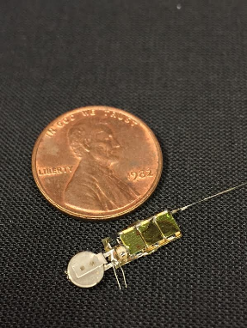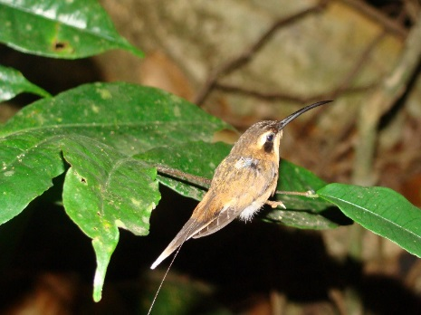Are you interested in cutting-edge radio electronics?
* Do you enjoy taking the lead in solving challenging engineering problems?
* Would you like to design devices that would have significant real-world applications?
* Do you value learning how to communicate and collaborate with scientists from outside your field of expertise?

If you answered yes to these questions, this project may be for you.

Across a wide range of disciplines in biology, the ability to follow the movement, physiology, and behavior, of free-living (i.e. wild) organisms has proven to be a major stumbling block. Traditional monitoring techniques, such as color-banding, stable isotope analysis, etc. provide extremely coarse information about animal behavior in both time and space. The advent of wildlife radio telemetry, however, has fundamentally altered how biologists study animal movement. Unfortunately, wildlife telemetry still suffers from a number of major setbacks that prevent it from solving some of the most significant questions about animal behavior.

Most notably, a major challenge for wildlife radio tracking is in obtaining high-accuracy position data of multiple individuals in a population. Most tracking technology used today by wildlife biologists involves the use of 1-3 researchers tracking animals while on foot (or by vehicle). This approach typically results in low-accuracy position information of just a few individuals for a relatively short period of time. A far better approach would be automated tracking of multiple individuals from a network of receivers on stationary towers. Such automated systems exist but suffer from a number of setbacks, including extremely low precision spatial information, high cost, and low power efficiency.

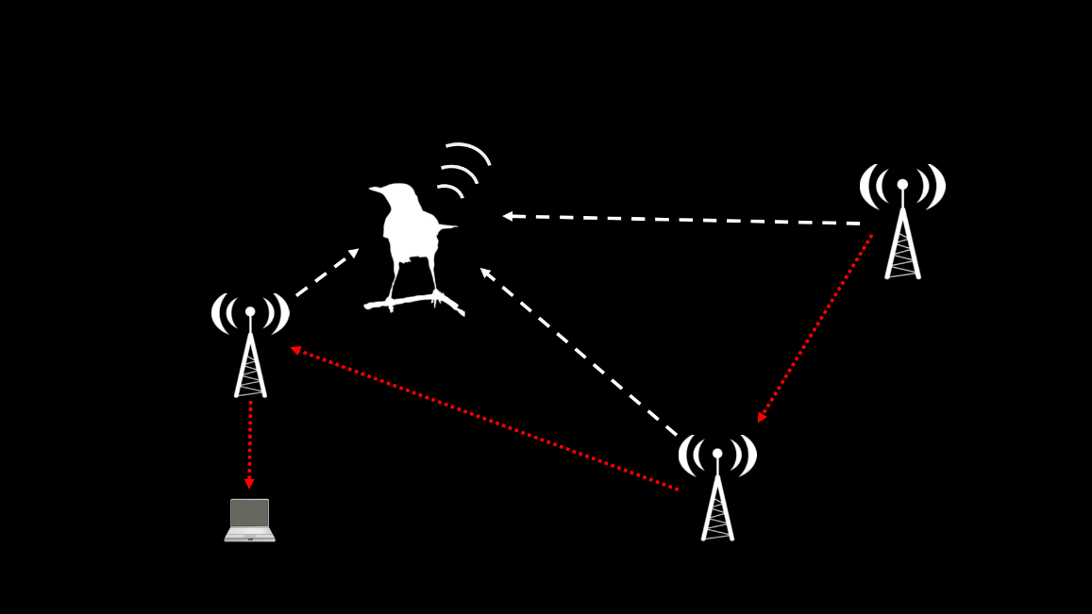This project seeks to create a system which sets a new standard for high-accuracy/precision spatial data on animal movements, using a technique known as phase interferometry for use in estimating the angle of arrival of radio signals. Such a system will require expertise with the fundamentals of radio electronics, digital signal processing, embedded systems design, and power management. As such, this project represents a unique opportunity for engineering students not only to refine pre-existing skillsets, but also to learn about new ones through working with other collaborators on the project.

If you like what you’ve read so far, please contact Julian Kapoor at [vak9@cornell.edu](mailto:vak9@cornell.edu) or Joe Skovira at [jfs9@cornell.edu](mailto:jfs9@cornell.edu) for more information.